Hannalla Consultancy

Company Profile 2019

**About Us**

Established in the market from over 30 years,

Hannalla Consultancy is a leading Egyptian-based, independent firm of consulting engineers, specializing in the Electrical design, development and construction of new projects, and the refurbishment of existing core processing plants and associated infrastructure. Hannalla Consultancy performs front-end engineering design, due diligence and independent reviews, process and infrastructure designs, technical studies, engineering, procurement, construction and management (EPCM) project deliveries, cost estimations and financial analysis services.

Hannalla Consultancy proudly acclaims to provide the best services and can undertake the responsibility to design, execute and manage the whole project. Please find our list of services and clientele that might speak of our work quality and experience. Our commitment with client is also backed up by extensive technical support, after sales service and comprehensive level of stock, for immediate response to customer’s requirements. If you have any queries for the pre-qualification of our company, please do not hesitate to contact us. We will be really glad to assist you.

**Mission**

Hannalla Consultancy highly values our clients’ needs for safe, reliable, and operationally efficient designs through cost-effective engineering and construction management services in a responsive, dynamic, and efficient way. Our Principals have built their careers understanding this truth and developed confidence and trusted long-lasting relationships within the industry by conducting our business with integrity, honesty, and hard work.

Our Mission Statement:

To provide responsive, safe, and trusted solutions to our clients with the highest-quality, most dependable, cost-effective engineering, design and construction management services in the energy industry.

**Vision**

Our vision for Hannalla Consultancy embodies who we are, individually and as a company, and reflects our core values and the path we follow in pursuit of providing our clients with unmatched performance, unparalleled accountability, and the highest-level of satisfaction in the industry.

To build trusted relationships and serve our clients through integrity, honesty, hard work and accountability in a collaborative, solution-oriented environment focused on providing the right solution instead of the easy solution, in the most efficient and cost-effective way possible.

**Values**

Hannalla Consultancy values are the cornerstone of how we do business and the basis for our guiding principles and the culture of the company. They set the benchmark for minimum expectations and are the driving force behind our clear communication, superior performance, and professional integrity

* Integrity
* Accountability
* Reliability
* Efficiency
* Quality
* Safety
* Innovation
* Collaboration
* Customizable Solutions

**Main Titles of Consultancy**

1. Consultant for Rutherford & Apelton for Nuclear Energy ( England )
2. Consultant for Ain Shams University 1987-1993
3. Consultant for Ain Shams Specialized Hospital 1987-2012
4. Consultant for Misinistry of Scientific Research 1992-1993
5. Consultant for Mubarak City for Research and Developemnt 1993-1996
6. Consultant for Egypt Real Estate and Tourist investment 1993-1996
7. Consultant for National Authority For Potable Water and Sewage 2007-2008
8. Consultant for Maadi Sports Club 2008-2014

**Projects:**

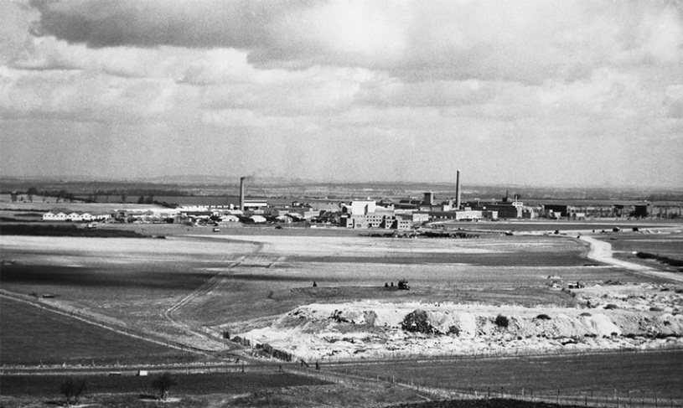**International Scope**

1. **Rutherford Appleton Laboratory** 1978-1979

Consultant for design of Nuclear Accelerators ( High Engine Physics Magnets)

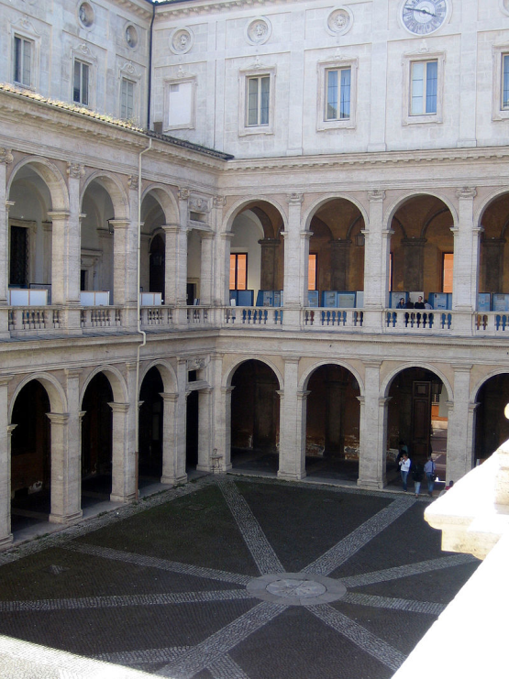

1. **Rome University** 1985

Solving Problems for Nuclear Power Station in Italy and designing protection with Smart industrial Intelligence

1. 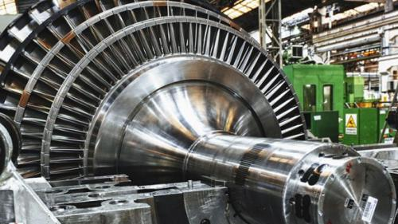**GE Canada** 19

Consultant for GE Candada in design of special high efficiency motors in Coordination with Windsor College Canada

**Local Scope**

**Strategic Projects:**

**1-Undergroung Metro Cairo**

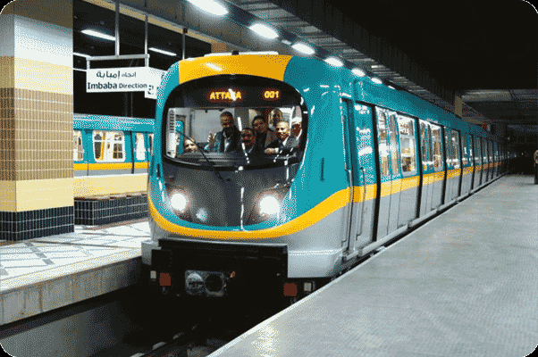Design and Supervision over installation for substations:

* El Sayeda Zeanab
* 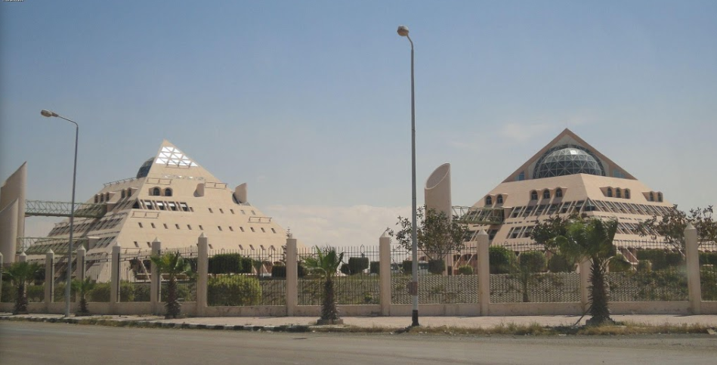Saad Zaghlool
* Mohamed Naguib
* Attba
* Orabi
* Mubarak ( El Shohada )

Design and Supervision over installation for Metro Electricity Stanby Power Feeding Substation

The substations is responsible for Emergency electricity feeding of:

* the metro line
* all electrical connected loads in the metro stations

Work in substation included:

* The generator back up units in case of power outage
* Automatic Control units in case of power outage
* Cables Network
* Distribution boards
* All Protection devices

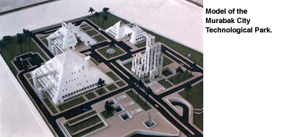**2-City of Scientific Research and Technological Applications**

(Mubarak City for Science Research and Technological Applications -Alexandria)

Former President Mubarak Inaugurated the city in August 2000

Design and Supervision over Installation for all Electrical City Systems which includes:

* Electrical Network
* 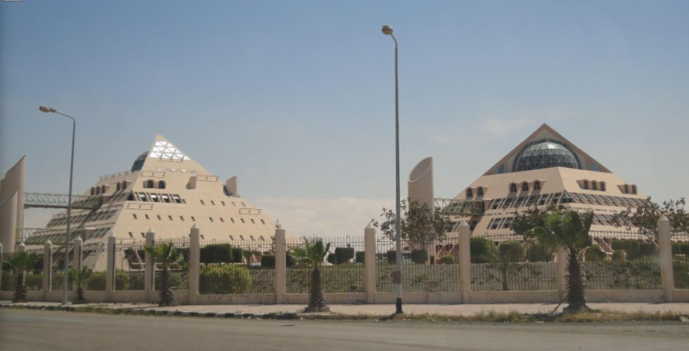Telephone Systems
* Network Cables
* Elevators
* Central Air Conditioning Units Power Feeding
* Transformers
* Standby Generator units in case of power outage
* Lighting system
* Fire Alarm

1. 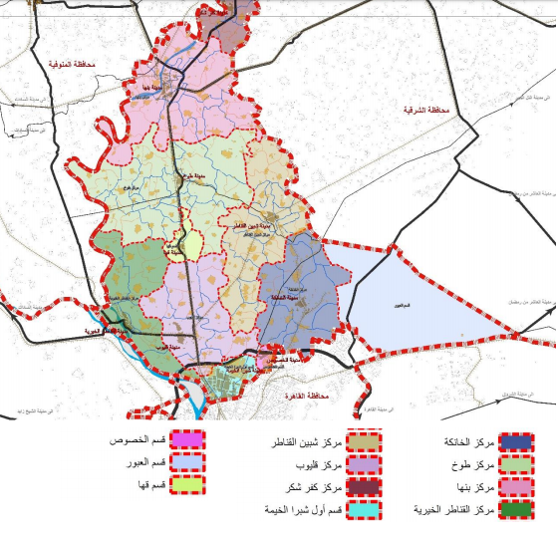**Strategic Planning for Kalyoub City:**

Design For Electrical works in the strategic Planning for Kalyoub City

Kalyoub City is 1018 KM2

With population 4.2 Million people which represents 23.2% of the capital Cairo Population

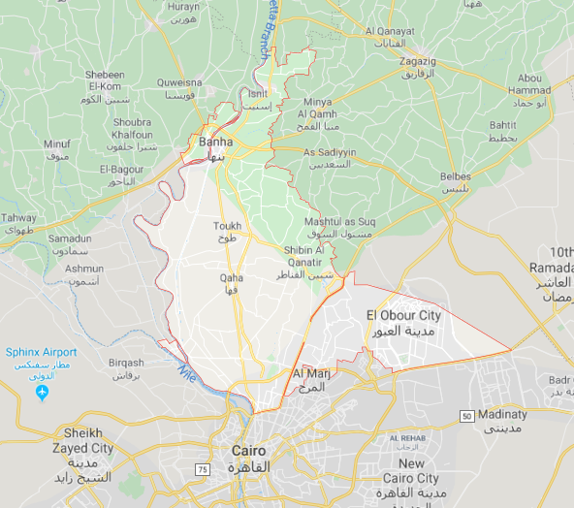

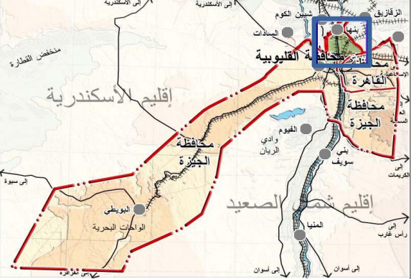

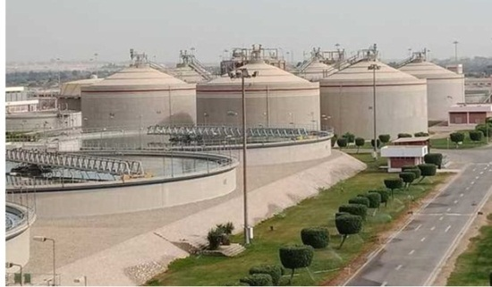**4-National drinking water and Sewege Authority**

1. 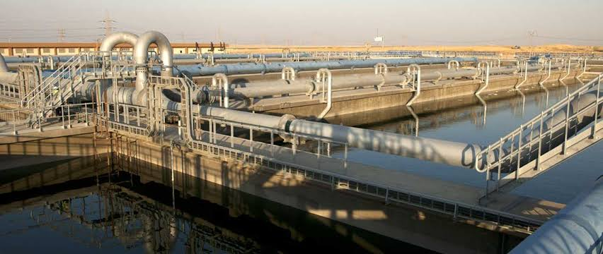Waste Water Substation- Arab Abo Mosa3ed – Helwan -Design and supervision over installation for changing the station control from conventional to SCADA System( Supervision Control & Data Acquisition)
2. 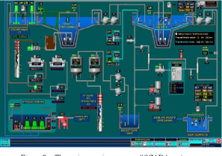Revision and approval for electrical works provided by the national drinking water and Sewege Authority
3. Solving different problems related to drinking water

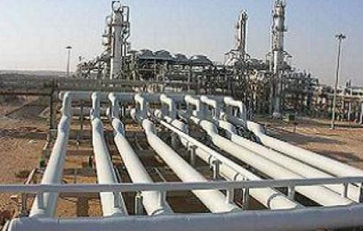**5-** **Petroleum Pipeline Cairo – Assyut (Mustered – Assyut)**

Solving Major problems for the buried pipeline from Cairo to Assyut using cathodic protection.

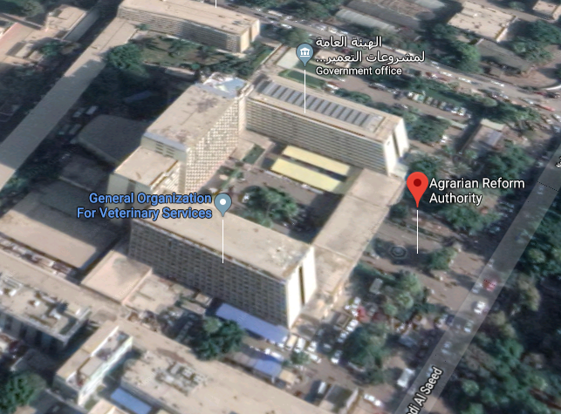**6-Agrian Reform Authority**

The Building consisted of (18 floor , Theatre, Cinema ,….)

Design and Supervision over installation:

* Electrical Network
* Telephone Systems
* Network Cables
* Transformers
* Standby Generator units in case of power outage
* Lighting system
* Fire Alarm

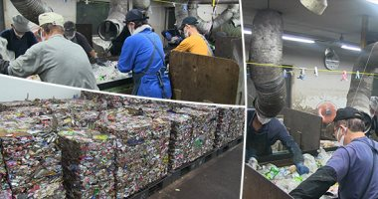**7-Garbage Transformation to Fertilizer-Zagazig**

Design and Supervision over installation of All Electrical system and Automated Production Lines

The project extended to 11 more factories across Egypt

**Governmental Buildings**

**1-Egypt Presidential Building:**

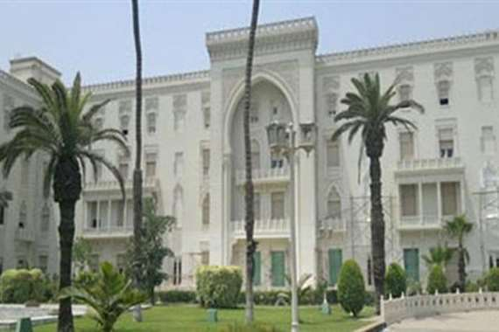Revision of Design & Supervision over installation for electrical work in the presidential building

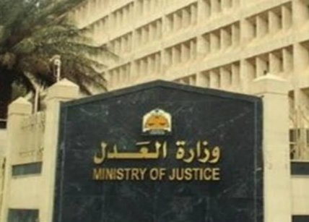**2-Ministry of Justice**

Design of Electric Substation with Back Up Diesel Generator sets

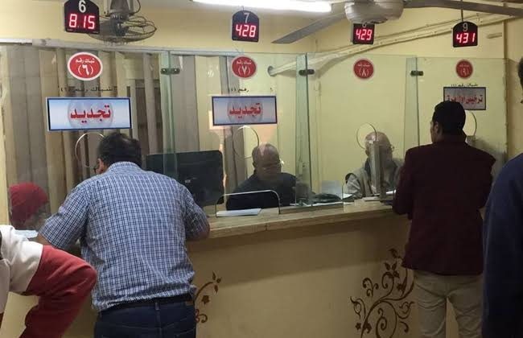**3-Central Traffic Department** ( Egypt Vehicle registration )

Design for back up diesel generator units in all branches across:

Cairo

Giza

Alexandria

**4- Artillery Officers** House - Armed Forces

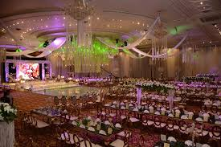Design and Supervision over Installation for all Electrical City Systems for celebration halls includes:

* Electrical Network
* Network Cables
* Elevators
* 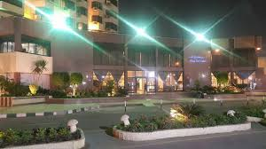Central Air Conditioning Units Power Feeding
* Lighting system
* Generator Emeregency standby Units
* Fire Alarm

**Compounds & Hotels**

**1-Ain Shams University Faculty Members Compound** ( North Coast Alexandria )

Design and Supervision over Installation for all internal and external electric networks:

* Network Cables
* 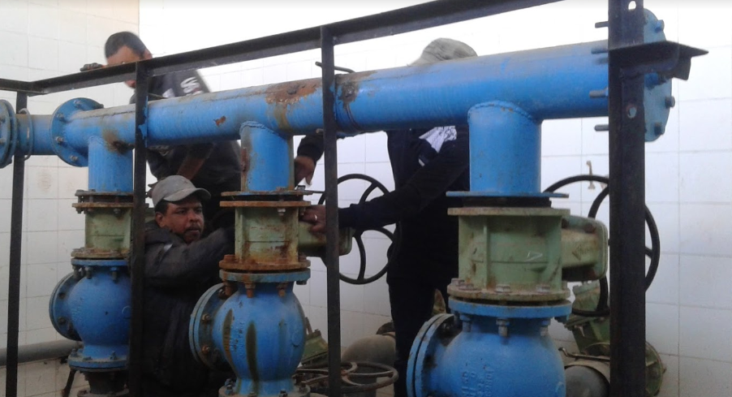Telephone Network
* Transformers
* Street Lighting
* Sewage substation
* Water Substation
* Standby Generator units in case of power outage
* Units Lighting (apartments, villas…)

The Compound consisted of

* 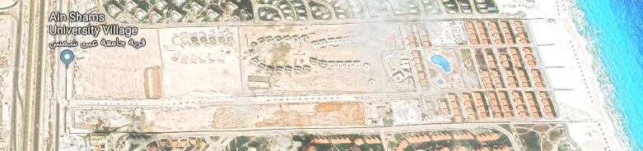600 units
* Hotel
* Mosque
* Courtyards
* Pools
* Streets
* Administration offices
* Market Place

**2- Long Beach Compound North Cost**

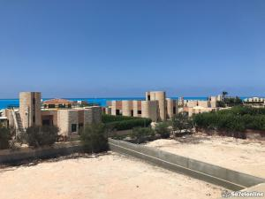The compound consisted of 250 units

Design and Supervision over Installation for all internal and external electric networks:

1. Network Cables
2. Telephone Network
3. Transformers
4. Street Lighting
5. Sewage substation
6. Water Substation
7. 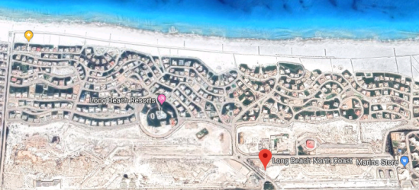Standby Generator units in case of power outage
8. Units Lighting (apartments, villas,…)

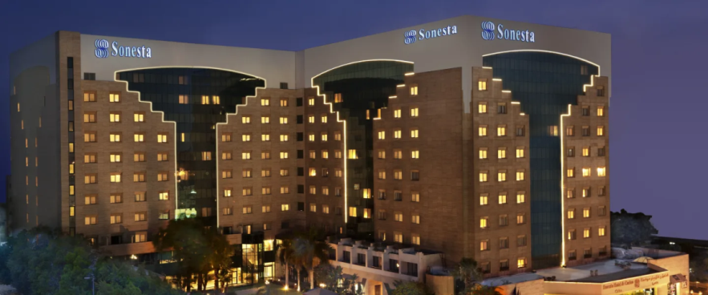**3-Sonesta Hotel Cairo:**

Revision of the electric network and all connected electrical loads

Completing a feasibility study for energy consumption reduction and power saving

**Other Buildings:**

**1-Hearing and Speech Institute Imaba**

Design and Supervision over Installation for Speech rooms with

Super Sound Insulation

**2-Abo El Feda Tower:**

Design and Supervision over Installation for the maintenance plan for the all electromechanical works which included:

* 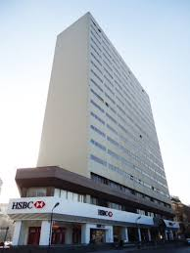Electrical Network
* Network Cables
* Elevators
* Central Air Conditioning Units Power Feeding
* Lighting system
* Generator Emeregency standby Units
* Fire Alarm

**3- Center For Environment & Development For The Arab Region & Europe – Cedare – Heliopolis**

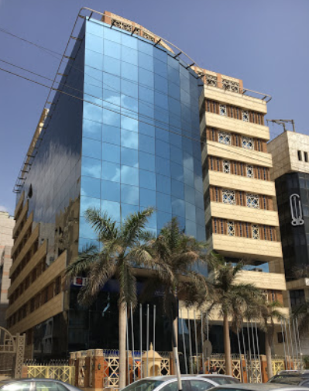Design and Supervision over Installation for external electric networks:

1. Network Cables
2. Telephone Network
3. Transformers
4. Lighting
5. Standby Generator units in case of power outage

**Banks:**

**1-Suez Canal Bank- Garden City:**

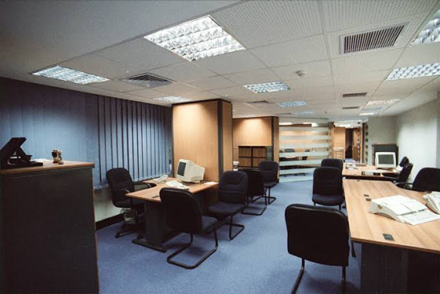Design and Supervision over Installation for the Low Voltage works which included:

* Electrical Network
* Network Cables
* Elevators
* Central Air Conditioning Units Power Feeding
* Lighting system
* Generator Emeregency standby Units
* Fire Alarm

**2- CIB Bank- Ghernata Branch:**

Design and Supervision over Installation for the Low Voltage works which included:

* Electrical Network
* 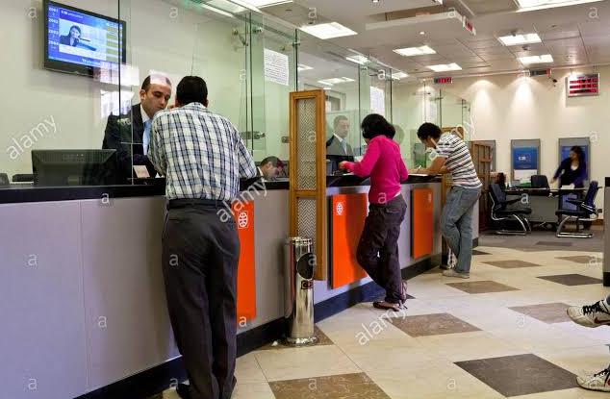Network Cables
* Elevators
* Central Air Conditioning Units Power Feeding
* Lighting system
* Generator Emeregency standby Units
* Fire Alarm

**3- Agricultural Bank of Egypt-**

A) Administrative Branch-New Cairo:

Design and Supervision over Installation for all electrical works which included:

* Electrical Network
* 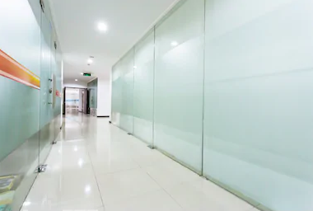Network Cables
* Elevators
* Medium Voltage
* Transformers
* Busways
* Central Air Conditioning Units Power Feeding
* Lighting system
* Generator Emeregency standby Units
* Fire Alarm
* CCTV

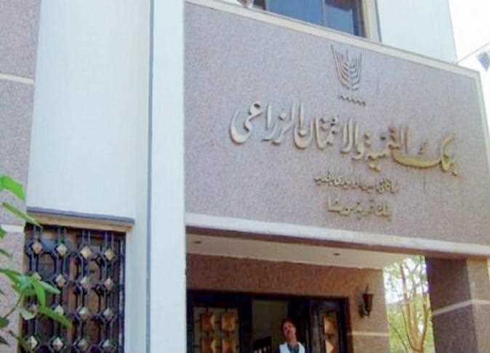B) Agricultural Bank of Egypt-Administrative Branch-Al Kasr Al Eeiny -Downtown:

Design and Supervision over Installation for all electrical works which included:

* Electrical Network
* Network Cables
* Elevators
* Medium Voltage
* Transformers
* Busways
* Central Air Conditioning Units Power Feeding
* Lighting system
* Generator Emeregency standby Units
* Fire Alarm
* CCTV

**4- National Investment Bank-**

A) Green Building – Smart Village Branch:

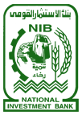Design and Supervision over Installation for all electrical works which included:

* Electrical Network
* Network Cables
* Elevators
* Medium Voltage
* Transformers
* 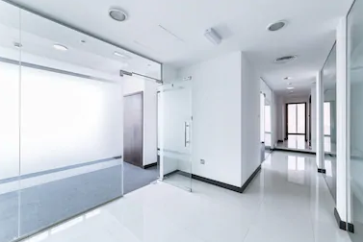Busways
* Central Air Conditioning Units Power Feeding
* Lighting system
* Generator Emergency standby Units
* Fire Alarm
* CCTV

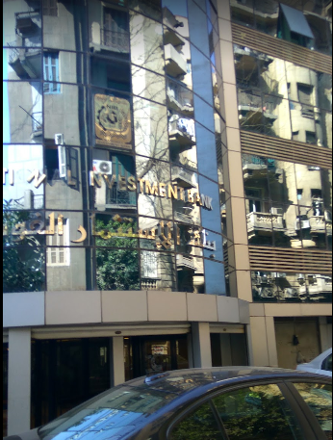B) National Investment Bank- Bab El Louk Branch-Cairo:

Design for all electrical works and Supervision over Installation for main Substation

C) National Investment Bank- Green Mountain-Cairo Branch:

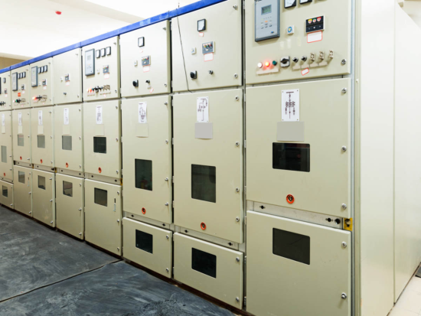Design for all electrical works and Supervision over Installation is in progress which includes:

* Electrical Network
* Network Cables
* Elevators
* Medium Voltage
* Transformers
* Busways
* Central Air Conditioning Units Power Feeding
* Lighting system
* Generator Emeregency standby Units
* Fire Alarm
* CCTV

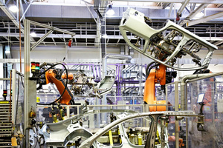**Factories:**

1. **BMW Factory- 6th of October City Cairo**:

Design and Supervision over Installation for all electrical network for car line production

* Electrical Network
* Network Cables
* Medium Voltage
* 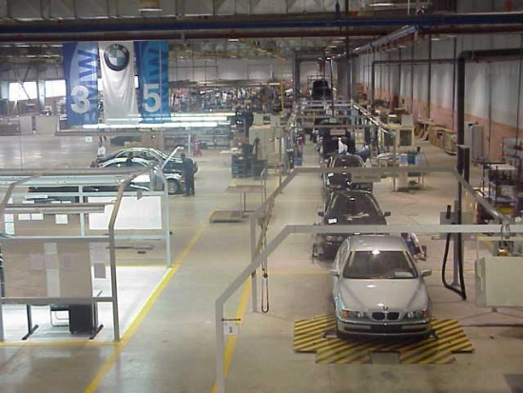Transformers
* Busways
* Lighting system
* Generator Emeregency standby Units
* Fire Alarm

1. 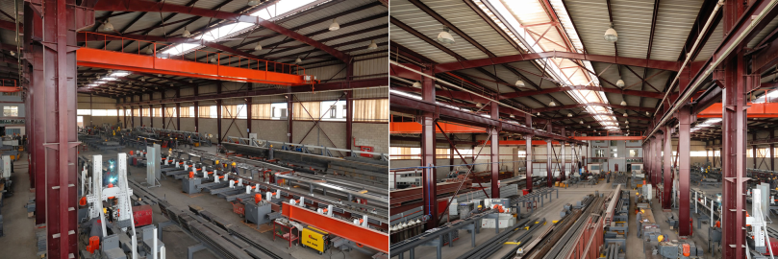**Alpha Factory for Metals:**

Design for all electrical network and lighting

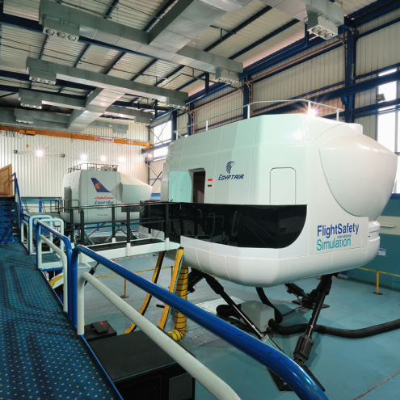

1. **Alpha Factory for Plastic:**

Design for all electrical network and lighting

1. **Gayed Tex For Spinning Industry- Obour City**

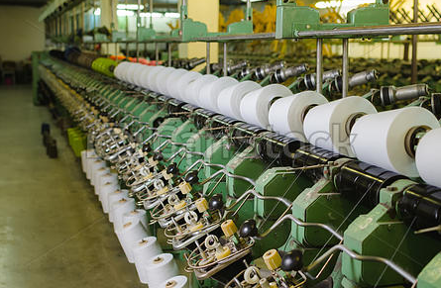Design and Supervision over Installation for all electrical power network ,lighting, transformers and Emergency back Up Generators

The Factory Electrical Capacity 5.3 Mwatt

1. **Gayed Tex For Polyester Industry – Obour City**

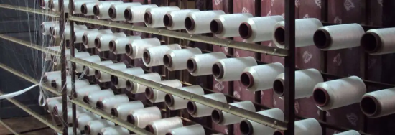Design and Supervision over Installation for all electrical power network, lighting, transformers and Emergency back Up Generators

The Factory Electrical Capacity 4 Mwatt

1. 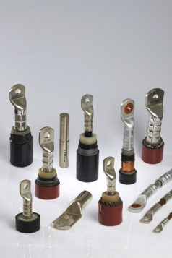**El Masala Factory for Electrical Cable Accessories-6th October City-Egypt :**

Industry – Obour City

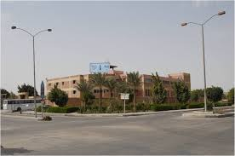Design and Supervision over Installation for all electrical network, transformers and Emergency back Up Generators

**Museums:**

1. 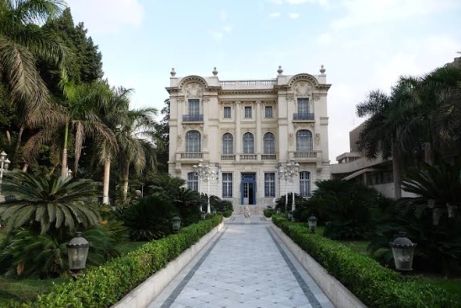**Mahmoud Khalil Musuem-Cairo:**

Design And Supervision over installation for all electrical works and safety Measures

The Musuem os famous for the well known painting of Zahret El Khsohkhash



1. **El Gezira Musuem-Cairo**

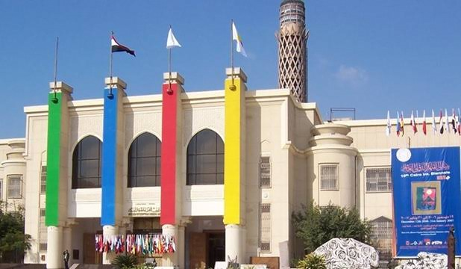Revision of Design And Supervision over installation for all electrical works

1. 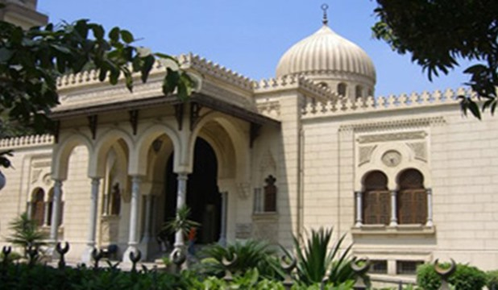**Museum of Islamic Ceramics - Cairo**

Revision of Design And Supervision over installation for all electrical works

1. 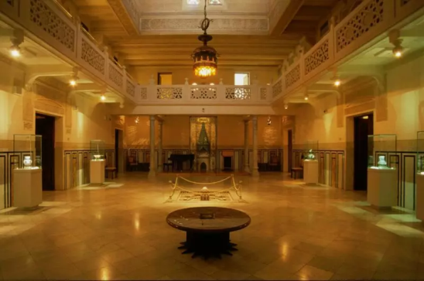 **Saffron Palace ( King Farouk Palace- Ain Shams University – Cairo)**

The palace is considered a Monument dated back to 1985 which needed extra work to preserve the sculptures and paintings

Design and Supervision over Installation for all Electrical City Systems which includes:

* Electrical Network
* Telephone Systems
* 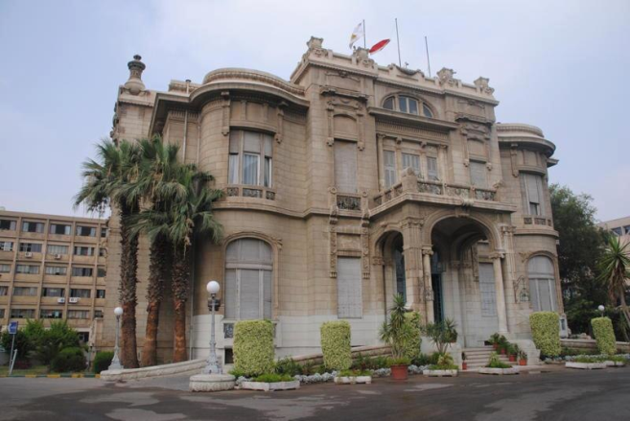Network Cables
* Elevators
* Central Air Conditioning Units Power Feeding
* Transformers
* Standby Generator units in case of power outage
* Lighting system
* Fire Alarm

**Hospitals:**

1. **Ains Shams Specialized Hospital**
2. Design & Supervision over installation for:
3. The hospital’s main substation which included:

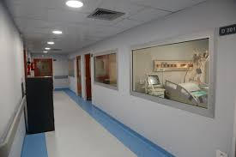1-transformers

2-Medium Voltage

3-Control

4-Generators

The operation of installation included the continuous supply of power to the hospital during installation

b. Operation rooms Electrical

c. Hospital warehouses and Corpse refregirator

d. Substation for Central HVAC system

1. 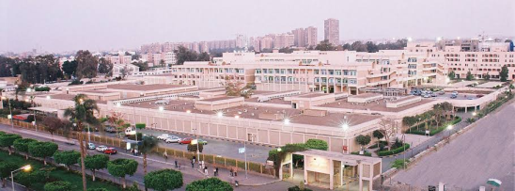Design for hospital Extension ( Neurosurgery)
2. Design for hospital Extension ( Oncology)
3. **Saint George Hospital-Heliopolis-Cairo:**

Design And Supervision over installation for all electrical works

1. 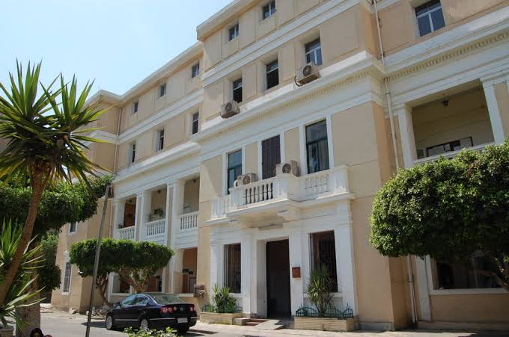**Demerdash Hospital-Cairo:**

Revision of Design and supervision over installation for reception& emergency building for all electrical works

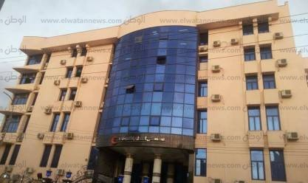

1. **Matareyya Hospital –Cairo:**

Design for renovation of all electrical works inside the hospital

**5-El Marwa Hospital**

Revision of all distribution boards, electricity network, standby electric station and hospital transformers

**6-Damanhour Teaching Hospital Extension ( 900 Bed )**

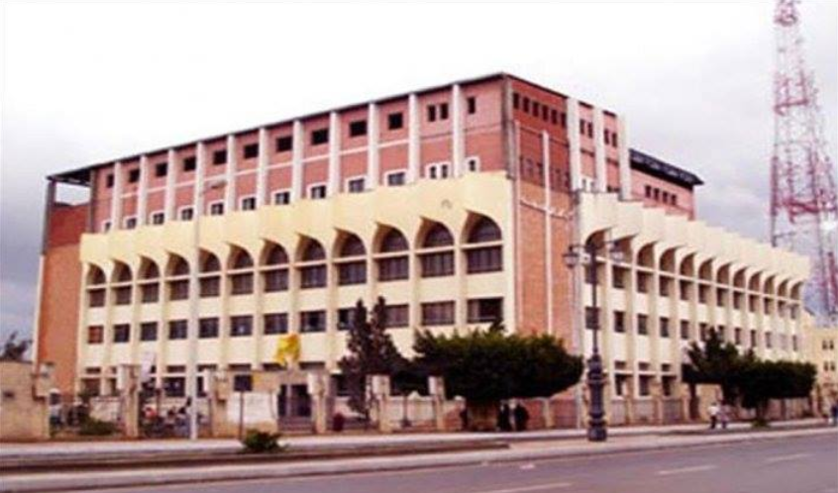Design and supervison over installation of all electrical systems in the hospital which includes but not limited to:

* Lighting
* Elevators
* Fire Alarm
* Central Air Conditioning
* X-ray Labs
* Intensive Care Units
* Distribution Electricity Network
* Generators
* Transformer

**7-Ayoub Hospital ( Nasr City- Cairo**)

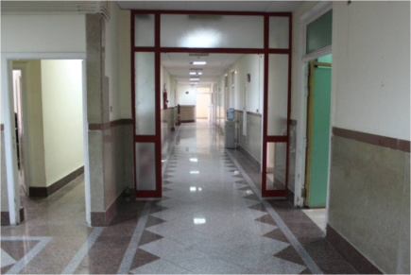Design and supervision over installation of all electrical systems in the hospital which includes but not limited to:

* Lighting
* Elevators
* Fire Alarm
* Central Air Conditioning
* X-ray Labs
* Intensive Care Units
* Distribution Electricity Network
* Generators
* Transformers

**Universities**

1. 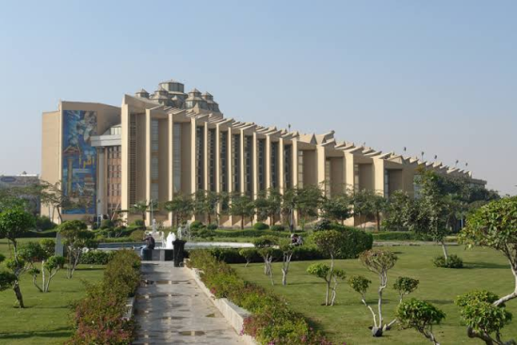***MUST University Extension***

Misr University for Science and Technology)The project included 5 faculties, Campus Extension Library and administrative offices

Design for All Electrical Networks which included

* Electrical Network
* Telephone Systems
* Network Cables
* 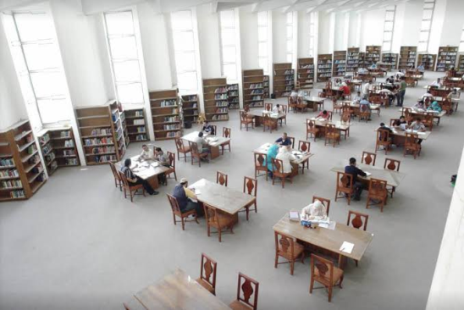Elevators
* Central Air Conditioning Units Power Feeding
* Ring Units
* Busways
* Transformers
* Standby Generator units in case of power outage
* Lighting system
* Fire Alarm
* CCTV

1. ***Ain Shams University***
2. 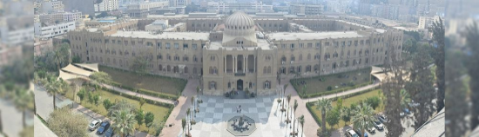**Ain Shams University Campus**:

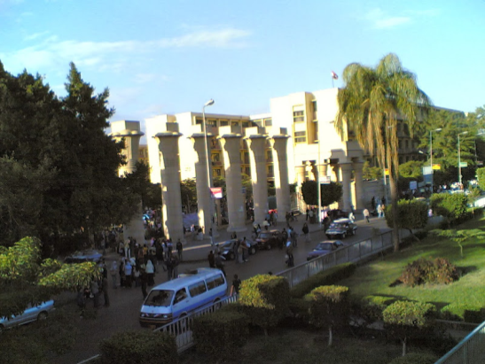Design and Supervision over installation for the medium voltage network of the main University campus

1. **Faculty of Science**

Design and Supervision over installation for:

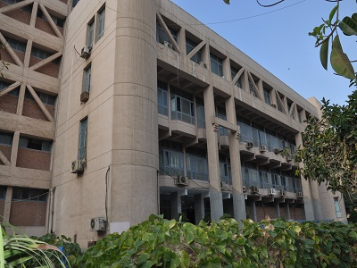

1. medium voltage substation which includes:

Transformers -Back Up Generators -Medium Voltage Ring Units-Busways

1. Low Voltage Network

Which included Lighting –Telephone networks-Sockets

1. **Faculty of Law**
2. 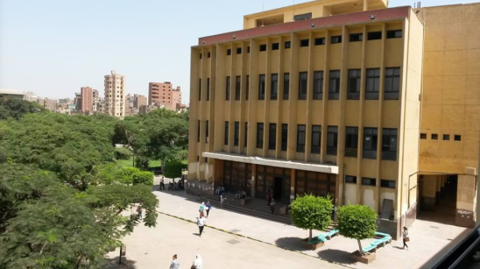medium voltage substation which includes:

Transformers -Back Up Generators -Medium Voltage Ring Units-Busways

1. Low Voltage Network

Which included Lighting –Telephone networks-Sockets

1. 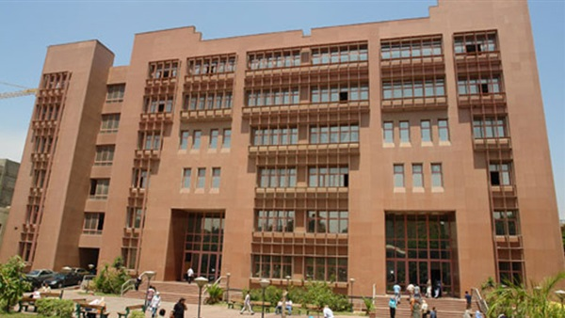**Faculty of Literature:**

Design and Supervision over installation for the Low voltage Network for the main students Session Halls

1. 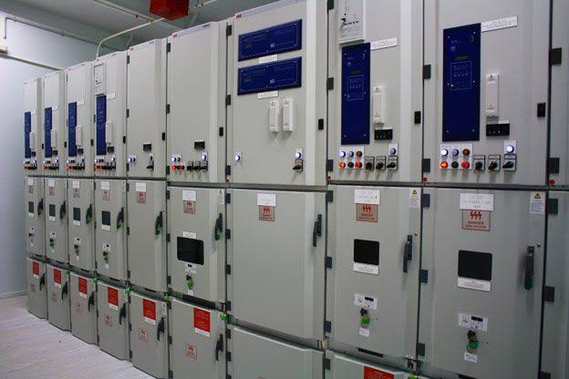**Faculty of Medicine**

Design and Supervision over installation for the medium voltage substation which includes:

Transformers -Back Up Generators -Medium Voltage Ring Units-Busways

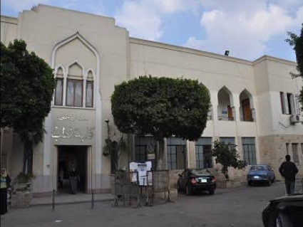

1. 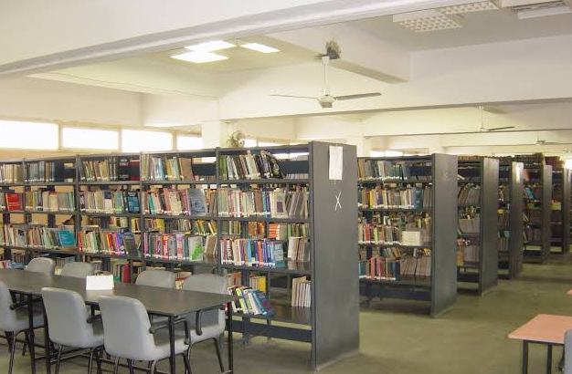**Library –Adminisistrative Building – Bank:**

Design & supervision over installation for Low voltage Electric Network

**6-Student Dorms - Gamasa –Ras Al Bar**

Design and Supervision over installation for the systems: Electric distribution network –Lighting - Fire Alarm- Elevators

**7-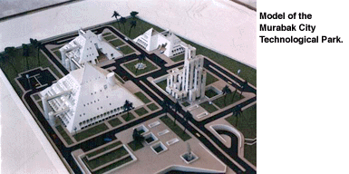Faculty of Engineering:**

Faculty of Engineering is located in a separate Campus

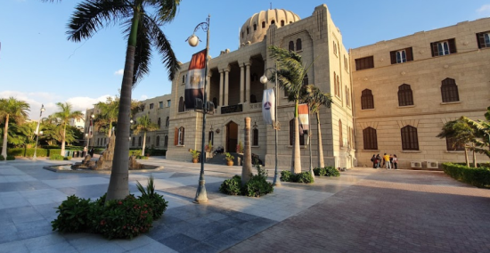A) Design and Supervision over installation for the medium voltage Faculty Campus substation which includes:

Transformers -Back Up Generators -Medium Voltage Ring Units-Busways

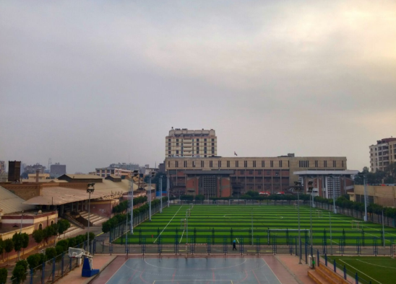B) Production Warehouse

Design for Electrical Lighting and Industrial Outlets

**8-Faculty of Girls for Arts, Science and Education**

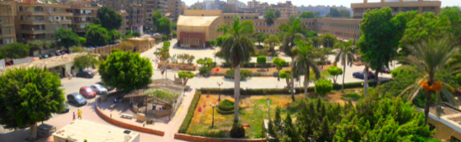Design and Supervision over installation for the medium voltage Faculty Campus substation which includes:

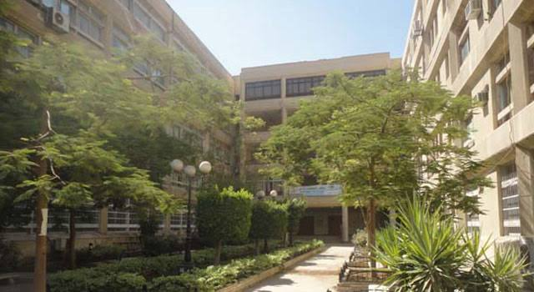Transformers -Back Up Generators -Medium Voltage Ring Units-Busways

Design and Supervision over installation for the systems: Electric distribution network –Lighting - Fire Alarm- Elevators

**About Dr. Adel Hannalla**

Founder & Owner of Hannalla Electrical Consultancy

Name : Adel Yousef Hannalla

Professor Electrical Power & Machines- Faculty of Engineering- Ain Shams University

Scientific Degrees:

1. BSC Electrical Engineering – Ain Shams University -1967
2. MSC Electrical Power Engineering – Ain Shams University 1969
3. Diploma Imperial College- London -1975
4. PHD Imperial College London –United Kingdom 1975

**Scientific Institutions**:



* IEE ( England 1975)
* IEEE USA 1975

**Contact Details**

Company Location: 12 El Khalifa El Maamoon St., Heliopolis ,Cairo, Egypt

PO: 11757

Phone: +20222592348 /+2022572509

Mobile: +201063965222 /+20101488002

Fax: +20224517275